2010 SPP Exxon-Mobil and PS-37 & 38 Load Addition Study Report

SPP Engineering Department, Planning Section

PUBLISHED: 4/23/2010
LATEST REVISION: 4/23/2010

Copyright © 2010 by Southwest Power Pool, Inc. All rights reserved.

Table of Contents

Executive Summary 2
Introduction 3
History and Background 3
Study Methodology 4
Scope 4
Summary of Modeling Methods and Analysis 5
Results of Analysis 6
Area Results 6
Slightly affected areas 9
Conclusions and Recommendations 10

Executive Summary
The objective of this study is to determine the effects within the entire SPP footprint due to the additional loads being served to the new Exxon-Mobil and TransCanada pumping Stations, PS-37 & 38. There will be a total of 106 MW of load added to the SPP footprint.

The general area studied is shown in the map below. The Exxon-Mobil load is located near the Perdue substation. The TransCanada loads, PS-37 & 38, are shown North and South of that location. All three new loads are for electrically driven pumping stations and processes.
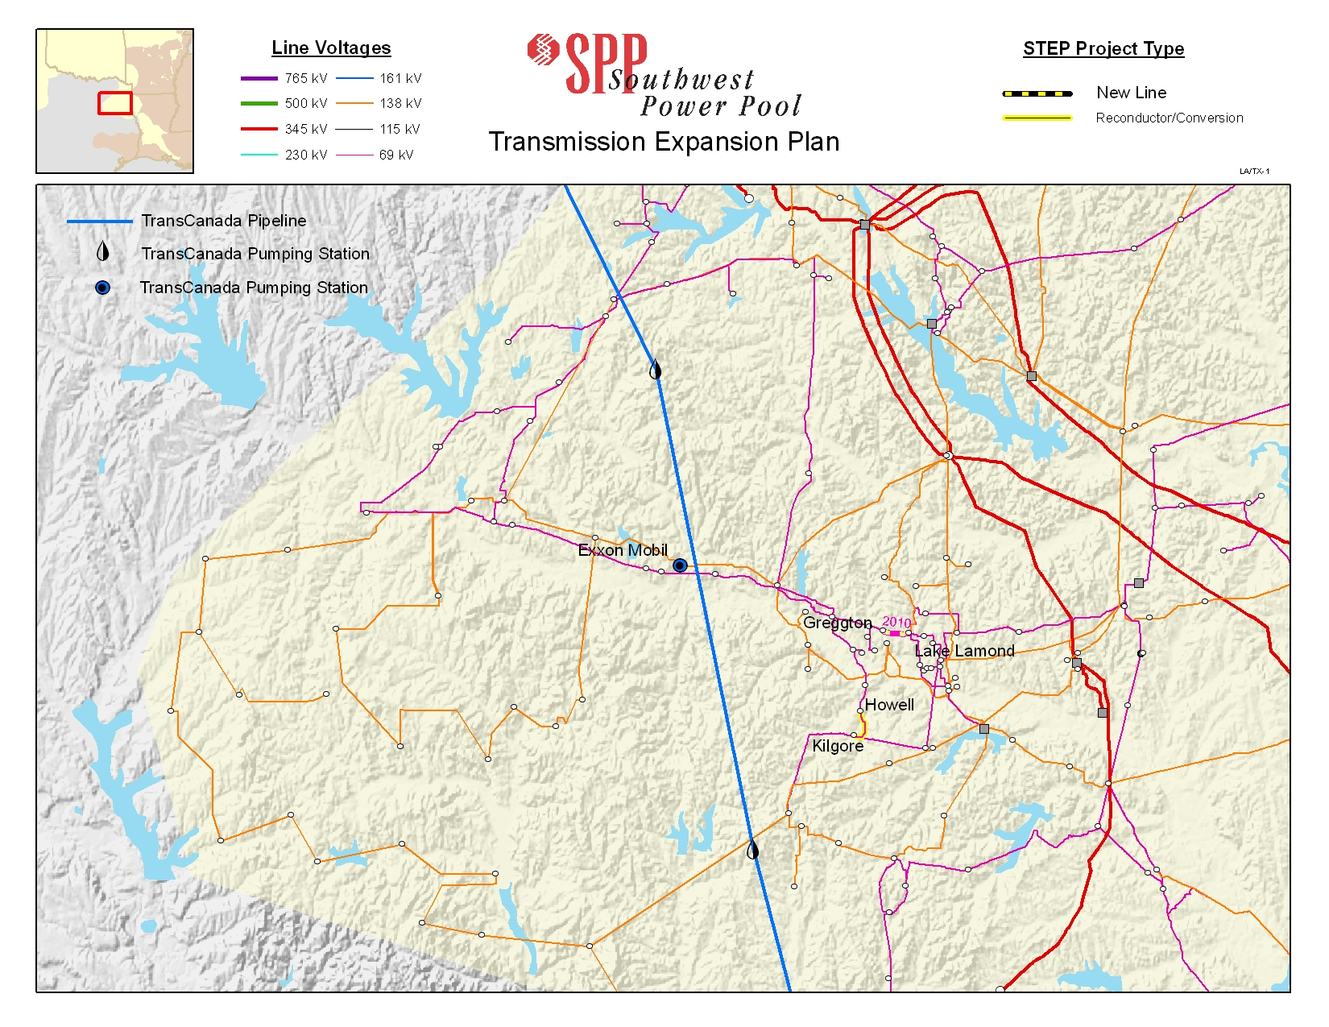

Three load flow models were evaluated: 1)The 2009 STEP RUN 6 models, with the all of the 2009 SPP Transmission Expansion Plan (STEP) projects added to them, 2) a set of models from step 1 with the Exxon-Mobil load and topology changes included in them, and 3) a third set of models created from the step 2 models with the TransCanada and PS 37 & 38 load and topology changes added.

AC contingency analysis was performed on model sets one and two, and then the results were compared. New voltage and thermal issues that were a result of the Exxon-Mobil were reviewed by the Transmission Owners and SPP Staff. A contingency analysis was also performed on the last set of models and then the results were compared with the previous results. New voltage and thermal issues that were a result of the TransCanada load addition were also reviewed by the Transmission Owners and SPP Staff.

A fourth AC Contingency Analysis was performed after adding all of the upgrade projects necessary to relieve the overloads and voltage issues associated with all of the new loads. This was done to verify that all of the problems were solved by the required projects. The results show that there were projects required due to the addition of each of the loads.

Introduction

History and Background

The Exxon-Mobil and the TransCanada load addition is taking place in the AEPW-ETEC area in East Texas. This “point of service” problem is within the SPP footprint. A previous study,

http://sppoasis.spp.org/documents/swpp/transmission/REPORT_2009%20SPP%20TransCanada%20Pipeline%20Study%20Report.pdf

which reflects the addition of the TransCanada loads, was previously completed by SPP staff in July 2009. However, the Exxon-Mobil 62 MW addition, in American Electric Power area, constituted a large load increase in a mainly rural area. See the map above.

The facilities of the following transmission operators are affected:

American Electric Power

Study Methodology

Scope

This study was performed according to the Study Scope as shown below. The Study Scope outlined the methods for creating the load flow models and for performing the reliability analysis.

Exxon-Mobil, PS-37 & PS-38 ETEC Load Study 2009

- OBJECTIVE: To determine the effects within the SPP footprint due to the additional load being served for the Exxon-Mobil and PS-37 & PS-38 Loads. The scheduled completion dates are as follows:
  - Exxon-Mobil ----------------------- 10/ 2010 62 MW
  - PS 37 & 38 each-------------------- 2011 2 MW
  - PS 37 & 38 each-------------------- 2012 9 MW
  - PS 37 & 38 each-------------------- 2013 9 MW
  - PS 37 & 38 each-------------------- 2014 22 MW

STUDY PROCESS

- Model Assumptions
  - Use the latest version of the 2009 SPP Transmission Expansion Plan (STEP) models
    - Version “RUN 6” with applicable upgrades proposed in the 2009 STEP
    - All seasons (2010 Winter Peak – 2019 Summer Peak)
    - All base and transactional scenarios (0-5)
    - Total of 36 models
  - Add the anticipated loads for Exxon-Mobil to obtain results. In addition add the anticipated loads for PS-37 & 38 and obtain the results inside/nearby the SPP footprint including Nebraska
  - All dispatch adjustments will follow SPP tariff studies merit order protocols

- Reliability Analysis
  - Assumptions
    - AC contingency analysis (N-1) on all load flow models using PSS/E
    - Contingencies
      - Single element (N-1) outages of:
        - SPP facilities 69kV and above
        - SPP generators
        - Entergy and AECI facilities 100kV and above
        - First tier companies 230kV and above
        - NPPD and OPPD at 69 kV and above
      - Multi-terminal outages as provided for the 2009 STEP by SPP members and first tier companies
    - Monitored Elements
      - SPP facilities 69kV and above (overload & voltage)
      - Entergy and AECI facilities 100kV and above (overload)
      - First tier companies 230kV and above (overload)
      - In NPPD and OPPD areas 69 kV and above
    - Apply SPP and NERC reliability standards

- Study Timeline
  - Finalize scope – January 9, 2010
  - Build models – February 6, 2010
  - Contingency results – February 12, 2010
  - Summarized results – February 19, 2010
  - Draft report – March 15, 2010
  - Final report – April 5, 2010

Summary of Modeling Methods and Analysis

The models included the most up to date information available to SPP Staff at the time that the ACCC runs were initiated. The reliability analysis was performed on the load flow models using PSS/E’s AC contingency analysis (N-1) software. All contingencies 69kV and above were taken in SPP (including NPPD, OPPD, and LES), AECI, LAGN, EES, and AMRN. All overload and voltage violations were then reported for SPP (including NPPD, OPPD, and LES) and EES. The violations that occurred before the Exxon-Mobil loads were compared to the violations that occurred after the new loads were added. This information was shared with the stakeholders and solutions were determined for the violations that were the result of the new loads.

The latter process was repeated with the TransCanada loads added into the second set of models. The ACCC run results were then compared with the first set of results in order to determine the effects of this additional load. Again this information was shared with the stakeholders and solutions were determined for the violations that were the result of the new loads.

The cost estimates included in the study are for the listed network upgrades only. The load serving upgrades and additions are beyond the scope of this study. This includes radial transmission lines, pumping station substations, step down transformers, and power factor correction capacitor banks.
The required projects for correcting thermal overloads and voltage violations are listed within the body of this report.

Results of Analysis

Area Results

The results of the contingency analysis showed that the addition of the loads had only zonal effects. However, some of the local exceptions are listed as follows:

Results obtained for just adding EXXON-MOBIL load

VOLTAGE and Thermal overloads correction projects:

2010 – Upgrade CT’s at Perdue -The Exxon-Perdue 138 kV line is overloaded for the any of the contingencies of the Coffee (Rayburn) – Jacksonville (SWE-RC-ETEC) 138 kV circuit 1 and the Coffee (RAYBURN) – New York (RAYBURN) 138 kV circuit 1. The limiting elements are 600/5 CT’s at Perdue substation. After a maintenance adjustment, the new rating will be changed from 215/237 MVA to 261/287 MVA.

2014 – Upgrade 1200 amp switches and breaker at Perdue and 1200 amp switch at Diana-The Diana-Perdue 138 kV line is overloaded for any of the contingencies of the Easton Rec-Knox Lee 138 kV Circuit 1, the Easton Rec-Pirkey 138 kV circuit 1, and the Harrison Road-Liberty City Tap 138 kV circuit 1. The limiting elements are the 1200 Amp switches and breakers at Perdue and a 1200 Amp switch at Diana. By upgrading this equipment, the line rating will change from 235/272 MVA to 261/303 MVA. That project cost is estimated at $500,000.

2014 – Upgrade 2.49 miles of 138 kV line between Eastex Switching Station and Whitney substation- The Eastex Switching Station-Whitney 138 kV circuit 1is overloaded for the contingency of the Easton Rec-Pirkey 138 kV circuit 1. The limiting element is a line section of 2.49 miles of 2-336 ACSR conductor. By upgrading this equipment, the line rating will change from 235/272 MVA to 287/316 MVA. That project cost is estimated at $3,000,000.

2017 - Ben Wheeler-Starr, 508362-508361, CLOSE the “OPEN TIE” by 2017 SP. This solution is for voltage violations at Bartons Chapel, Ben Wheeler, Antioch, Cedar, Coffee, New York, Walton, etc. due to the Coffee (RAYBURN)-Jacksonville (SWE-RC-ETEC) 138 kV circuit 1 contingency.

2019 – Upgrade 1200 Amp switches at Wilkes and Welsh Reserve and 1200 Amp wave trap at Wilkes- The Welsh Rec-Wilkes 138 kV line, is overloaded for the contingency of the Lone Star South-Pittsburg 138 kV circuit 1. The limiting elements are the 1200 Amp switches at Wilkes and Welsh Reserve and a 1200 Amp wave trap at Wilkes. By upgrading this equipment, the line rating will change from 239/287 MVA to 239/301 MVA. That project cost is estimated at $500,000.

2019 - A new 28.8 MVAR capacitor bank at Winnsboro on the 138 kV bus, 508317, can relieve contingency driven area voltage violations in the 2018 summer. (Please note that this 2019 date is later changed to 2014 due to the addition of the TransCanada load.

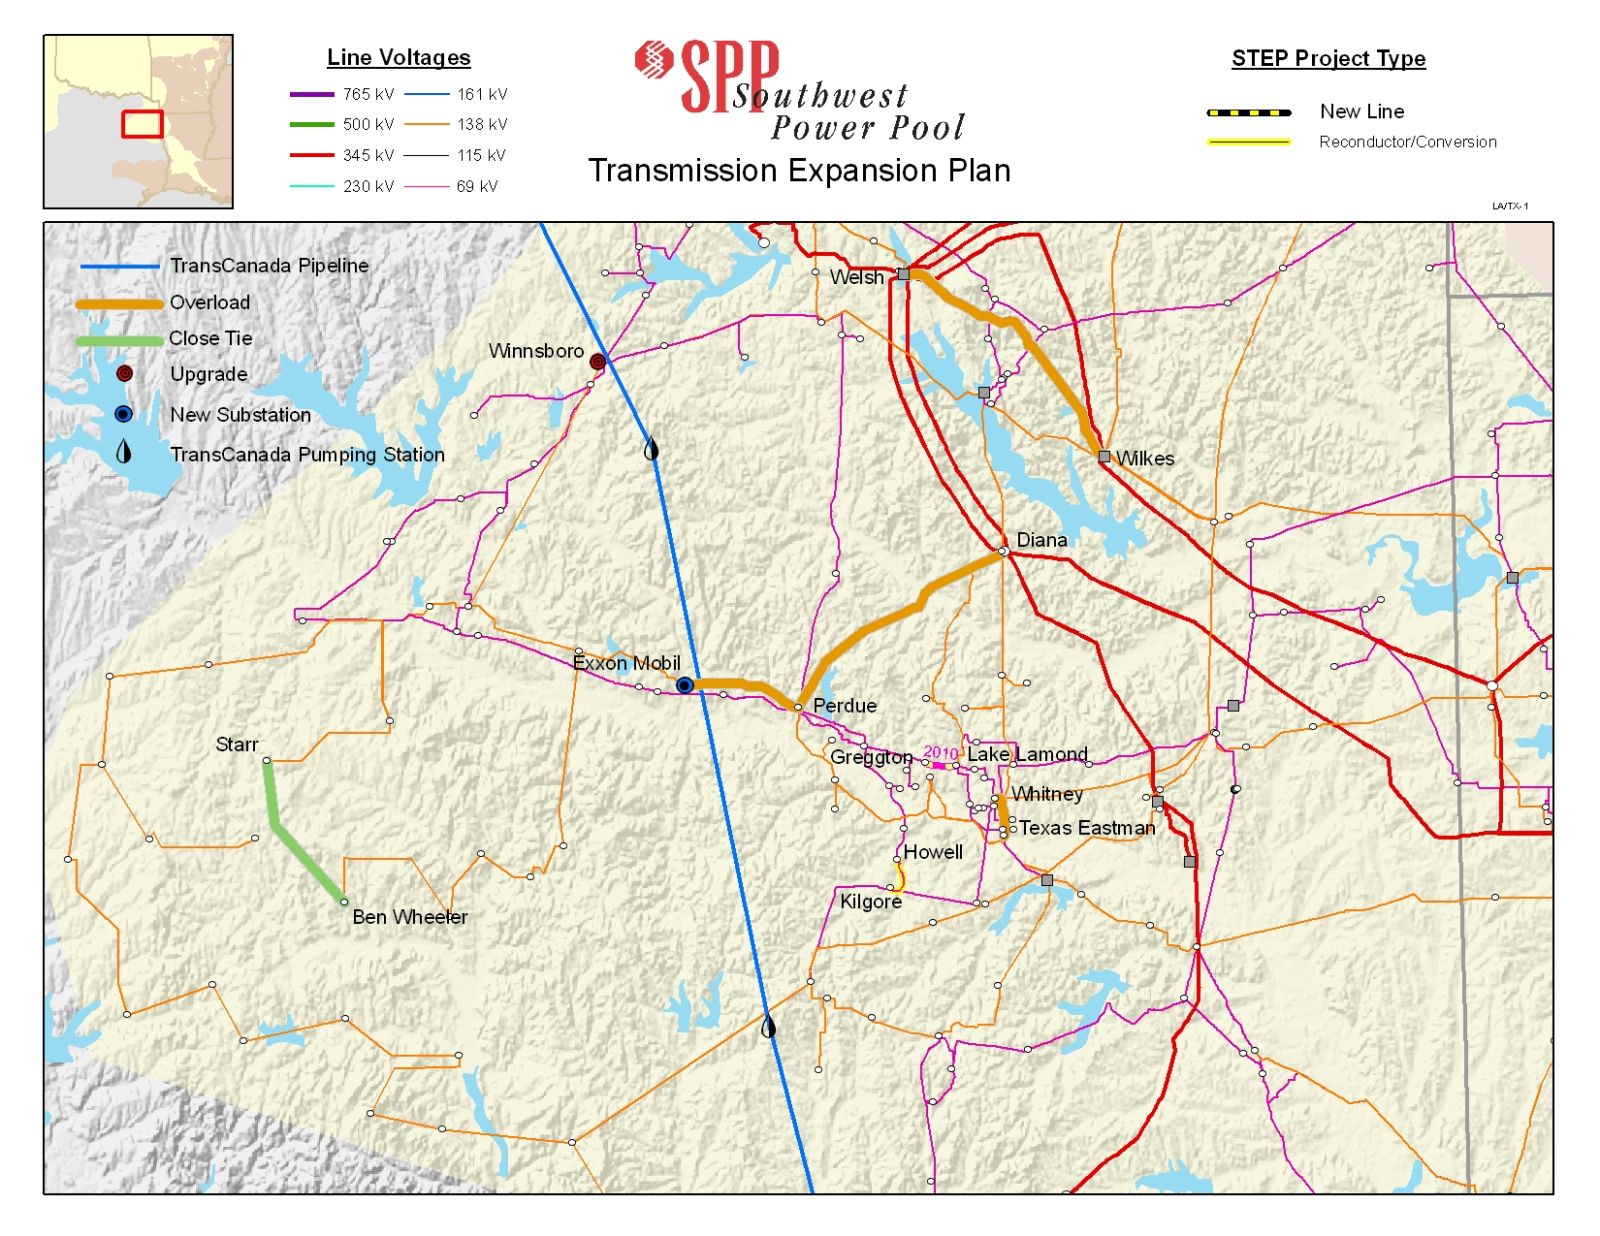

Results obtained for adding the TransCanada loads in addition to the EXXON-MOBIL load

VOLTAGE and Thermal overloads correction projects additional projects:

2014 - Install a new 28.8 MVAR capacitor bank at Winnsboro on the 138 kV bus, to relieve contingency driven area voltage violations in the 2014 summer. The additional TransCanada load required the advancement from 2019 to 2014.. The project cost is estimated to be $1,166,400.

2014 – Install new 28.8 MVAR capacitor bank at Petty on the 138 kV bus, 508310, to relieve contingency driven area voltage violations in the 2014 summer. That project cost is estimated to be $1,166,400.

2016 – Install a new 28.8 MVAR capacitor bank, with 2 block switching, at Exxon-Mobil on the 138 kV bus, 508369, can relieve contingency driven area voltage violations in the 2016 summer. That project cost is estimated to be $1,166,400.

2019 – Upgrade 1200 amp 138 kV switches at Chapel Hill and Wilkes Reserve- The Chapel Hill Rec – Welsh Reserve 138 kV line, 508355-508337 and is 4.29 miles in length, is overloaded for the contingency of the Lone Star South-Pittsburg 138 kV circuit 1. The limiting elements are the 1200 Amp switches at Chapel Hill and Wilkes Reserve. By upgrading this equipment, the line rating will change from 239/287 MVA to 239/301 MVA. That project cost is estimated at $500,000.

2019 – Upgrade 138 kV conductor between Diana and Perdue substations-The Diana-Perdue 138 kV line, 21.84 miles in length, is overloaded for the contingency of the Harrison Road-Liberty City Tap 138 kV circuit 1. The limiting element is the conductor between Diana and Perdue. The minimum line rating will change from 261/303 to 430/473 MVA. That project cost is estimated at $21,840,000.

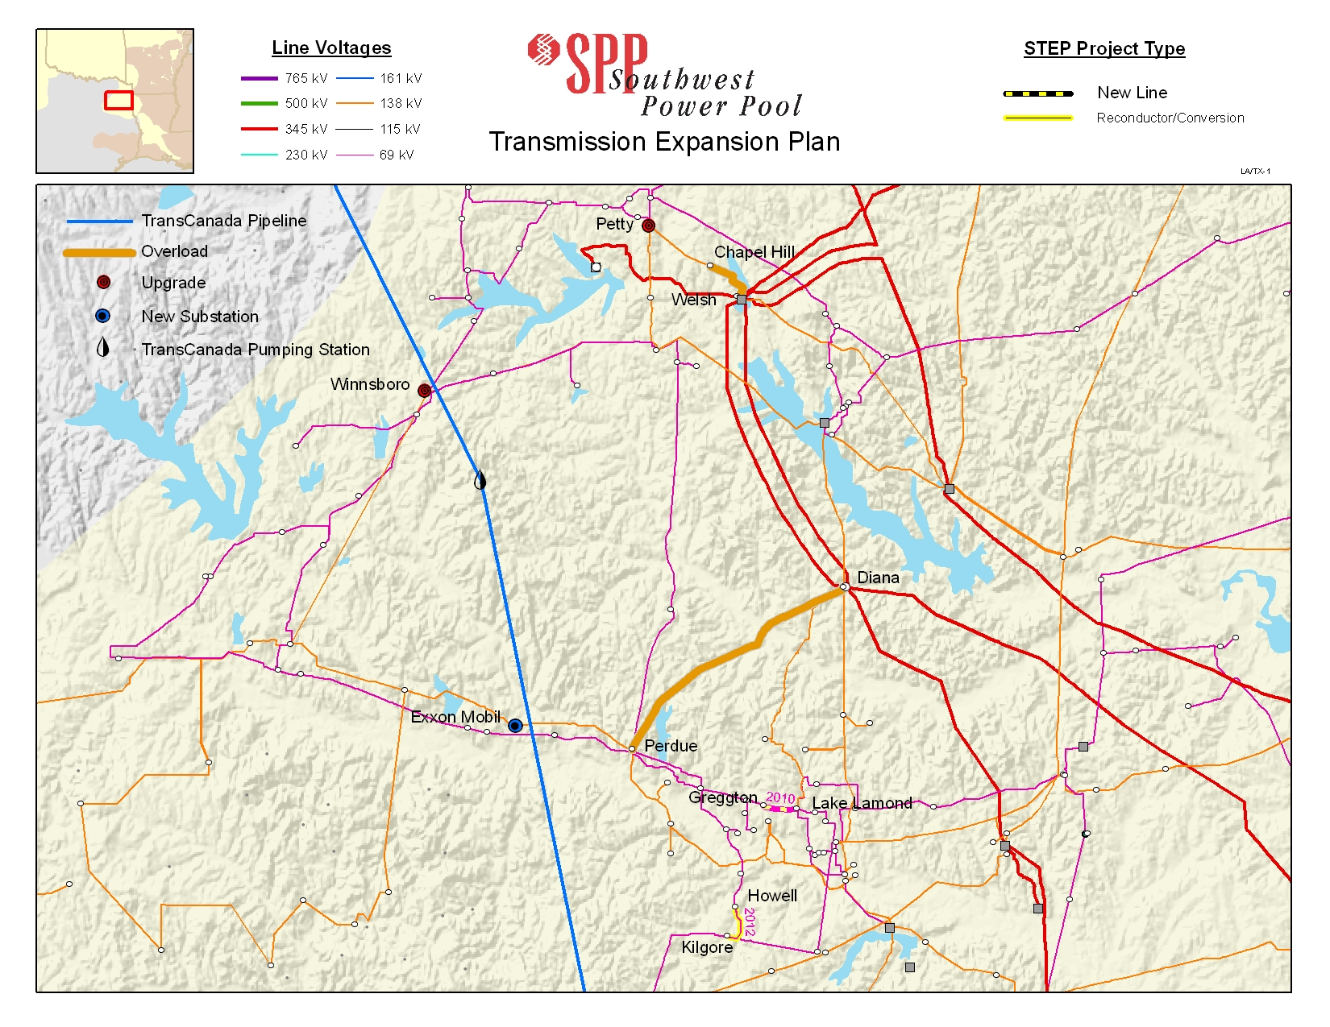

Conclusions and Recommendations

When the Exxon-Mobil load was analyzed on the SPP system, a number of voltage and thermal problems occured in multiple areas in SPP. To relieve these violations, six reliability projects will need to be completed. This information will be incorporated into the 2010 SPP Transmission Expansion Plan as needed.

1. DIANA - PERDUE 138KV CKT 1 equipment upgrade by 2014
2. EXXONM 4 138.00 - PERDUE 138KV CKT 1 equipment adjustment by 2011
3. TEXAS EASTMAN - WHITNEY 138KV CKT 1 re-conductor 2.49 miles by 2014
4. BEN WHEELER_STARR CLOSE the OPEN TIE by 2017
5. WELSH REC - WILKES 138KV CKT 1 equipment upgrade by 2019
6. WINNSBORO 28.8 MVAR new capacitor bank by 2019

When the PS-37 and PS-38 load addition was analyzed on the SPP system, a number of voltage problems occured within SPP. To relieve these violations, four new reliability projects will need to be completed. This information will be incorporated into the 2010 SPP Transmission Expansion Plan as needed.

6. a. WINNSBORO 28.8 MVAR new capacitor bank by 2014 not 2019 as above in # 6
7. PETTY, 508310, 28.8 MVAR new capacitor bank by 2014 SP
8. EXXON-MOBIL, 508369, 28.8 MVAR new capacitor bank with 2 block steps by 2016
9. WELSH REC – CHAPEL HILL 138 kV CKT 1 equipment upgrade by 2019
10. DIANA – PERDUE 138 KV CKT 1 re-conductor 21.85 miles by 2019

The project costs for the following owners are:

Transmission Owner | 2014 | 2016 | 2019 | Total
AEPW | $5,832,800 | $1,166,400 | $22,565,000 | $29,564,200

